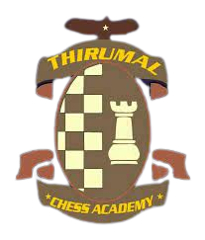
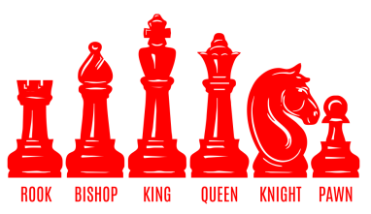
PERI CHESS TROPHY-2023
State Level Inter Collegiate Chess Tournament - Men & Women
(An IQAC Initiative on the occasion of National Sports Day)
Organised by
DEPARTMENT OF PHYSICAL EDUCATION
PERI COLLEGE OF ARTS AND SCIENCE
Affiliated to University of Madras
Technical Support by
THIRUMAL CHESS ACADEMY
Day & Date Venue
Tuesday PERI Knowledge Park, Mannivakkam
29th August 2023 Chennai- 600 048, Tamil Nadu, India.
Category/ Prize | 1st Place | 2nd Place | 3rd Place | 4th-Place to 10th Place
Men | Rs.7,500/-+ Trophy | Rs.5,000/- + Trophy | Rs.2,500/- + Trophy | Trophy
Women | Rs.7,500/-+ Trophy | Rs.5,000/- + Trophy | Rs.2,500/- + Trophy | Trophy

Total Trophies: 20 Total Cash Prize: Rs.30,000
Entry Fee: Rs.200/*- per player can be sent by DD / Cheque in favour of “PERI College of Arts and Science, Chennai-48”. Last Date: 25.08.2023.
*Entry fee includes refreshments during FN and AN and Lunch.

For all communications, Queries and Registration
Dr. V. PADMANATHAN Miss. J. JENO RAJI
Director of Physical Education Asst. Director of Physical Education
Mobile No. +91 80724 60318. Mobile No +91 8825634765
E-mail for correspondence: perichesstrophy@gmail.com
Visit us www.peri.education

